**A**

**STUDY**

**ON**

**ADVERTISING EFFECTIVENESS**

**WITH REFERRENCE TO HINDUSTHAN COCA–COLA BEVERAGES PVT LTD., SRIKALAHASTHI, A.P**

Submitted to

**JAWAHARLAL NEHRU TECHNOLOGICAL UNIVERSITY ANANTAPUR,**

ANANTAPURAMU

In partial fulfilment of the requirements for the award of the degree of

**MASTER OF BUSINESS ADMINISTRATION**

Submitted by

**Shaik Vazeed**

**(H.T.NO: 205N1E0043)**

Under the guidance of

**Mrs. C. UMADEVI, MBA, (ph. D)**

Assistant professor

**DEPARTMENT OF BUSINESS ADMINISTRATION**

**ANNAMACHARYA P.G COLLEGE OF COMPUTER STUDIES**

New Boyanapalli, Rajampeta-516126, A.P

(Affiliated to JNTUA, Anantapuramu)

**(2022)**

**ANNAMACHARYA P.G COLLEGE OF COMPUTER STUDIES**

New Boyanapalli, Rajampet-516126, AP

(Affiliated to JNTUA, Ananthapuramu)

**CERTIFICATE**

This is to certify that the Project Report entitled **“Advertising effectiveness of Hindustan Coca-Cola Beverages pvt ltd.,”** is submitted by **Mr. Shaik Vazeed, H.T No 205N1E0043,** in partial fulfillment of the requirements for the award of the degree of **Master of Business Administration***,* to the Department of MBA, under our guidance. This has not been submitted to any other university or institution for the award of any degree/diploma/certificate.

**Signature of the Guide Signature of the Principal**

**(Mrs. C.UMADEVI) (Dr. D.J.SAMATHA NAIDU)**

**Signature of the External Examiner**

**DECLARATION**

I do here by declare that this project report entitled **“Advertising effectiveness of Hindustan Coca-Cola Beverages pvt ltd.,”** is submitted by me to the Department of Business Administration, Annamacharya P.G. College of Computer Studies, Rajampet, is bonafide work carried out by me and this is not submitted to any other university or institution for the award of any degree/ diploma/ certificate.

**Date: Signature of the Student**

**Place:** Rajampet  **(SHAIK VAZEED)**

**H.T.No.205N1E0043**

**ACKNOWLEDGEMENT**

First, I would like to thank my Project Guide **Mrs. C. UMADEVI*,*** Assistant Professor for her constructive comments, assistance and guidance starting from the inception of the project idea up to the completion of the work. Without exaggeration, had it not been for her support and cooperative assistance the finalization of the project report would not have been possible.

My profound thanks to the Principal **Dr. D.J. SAMATHA NAIDU**, Head of the Internal Departmental Committee of Annamacharya PG College of Computer Studies, for her advice, critical comments and fast response for all my requests starting from the synopsis preparation and up to the completion of the report.

Finally, I wish to express my gratitude to **K. Venugopal Rao**, Manager, Coca-Cola pvt, ltd. who gave irreplaceable support to grasp the field in a new perspective.

**SHAIK VAZEED**

**TABLE OF CONTENTS**

|  |  |  |
| --- | --- | --- |
|  | **CONTENTS** | **PAGE NO** |
| **CHAPTER I**  **INTRODUCTION** | * 1. Introduction   2. Industry Profile   3. Company Profile | 01-24 |
| **CHAPTER II**  **RESEARCH METHODOLOGY** | 2.1 Need of The Study  2.2 Problem Definition  2.3 Objectives of The Study  2.4 Scope of The Study  2.5 Hypothesis  2.6 Research Design  2.7 Data Sources  2.8 Sample Design  2.9 Tools of Analysis  2.10 Limitations of The Study | 25-27 |
| **CHAPTER III**  **DATA ANALYSIS AND INTERPRETATION** | 3.1 Representing gender of respondent  3.2 Representing Age of respondent  3.3 Representing Occupation of respondent  3.4 Representing Purchase of cold drink by respondent  3.5 Representing frequently Purchase of cold drink by respondent  3.6 Representing Cold drink like by respondent  3.7 Representing flavour of Cold drink like by respondent  3.8 Representing quantity prefer by respondent  3.9 Representing spending on Coca-Cola per week by respondent  3.10 Representing advertisement seen by respondent  3.11 Representing rating advertisement by respondent  3.12 Representing rating advertisement by respondent  3.13 Representing rating advertisement by respondent  3.14 Representing where advertisement seen by respondent  3.15 Representing often seen of advertisement by respondent  3.16 Representing company advertisement liked by respondent  3.17 Representing media channel of Coca-Cola advertisement watch by respondent  3.18 Representing factor of Coca-Cola that attracts to respondent  3.19 Representing advertisement effects on Consume of respondent  3.20 Representing effective media of advertisement by respondent  3.21 Representing reason of advertisement like by respondent  3.22 Representing effectiveness of advertisement by respondent  3.23 Representing necessary of advertisement by respondent  3.24 Representing slogan of advertisement by respondent  3.25 Representing slogan like most by respondent | 28-53 |
| **CHAPTER IV**  **FINDINGS, SUGGESTIONS AND CONCLUSION** | 4.1 Findings  4.2 Suggestions  4.3 Conclusion | 54-56 |
| **APPENDIX** | Questionnaire  Bibliography |  |

**LIST OF TABLES**

|  |  |  |
| --- | --- | --- |
| **TABLE NO.** | **TITLE OF THE TABLES** | **PAGE NO** |
| 3.1 | Representing gender of respondent | 28 |
| 3.2 | Representing Age of respondent | 29 |
| 3.3 | Representing Occupation of respondent | 30 |
| 3.4 | Representing Purchase of cold drink by respondent | 31 |
| 3.5 | Representing frequently Purchase of cold drink by respondent | 32 |
| 3.6 | Representing Cold drink like by respondent | 33 |
| 3.7 | Representing flavour of Cold drink like by respondent | 34 |
| 3.8 | Representing quantity prefer by respondent | 35 |
| 3.9 | Representing spending on Coca-Cola per week by respondent | 36 |
| 3.10 | Representing advertisement seen by respondent | 37 |
| 3.11 | Representing rating advertisement by respondent | 38 |
| 3.12 | Representing rating advertisement by respondent | 39 |
| 3.13 | Representing rating advertisement by respondent | 40 |
| 3.14 | Representing where advertisement seen by respondent | 41 |
| 3.15 | Representing often seen of advertisement by respondent | 42 |
| 3.16 | Representing company advertisement liked by respondent | 43 |
| 3.17 | Representing media channel of Coca-Cola advertisement watch by respondent | 44 |
| 3.18 | Representing factor of Coca-Cola that attracts to respondent | 45 |
| 3.19 | Representing advertisement effects on Consume of respondent | 46 |
| 3.20 | Representing effective media of advertisement by respondent | 47 |
| 3.21 | Representing reason of advertisement like by respondent | 48 |
| 3.22 | Representing effectiveness of advertisement by respondent | 49 |
| 3.23 | Representing necessary of advertisement by respondent | 50 |
| 3.24 | Representing slogan of advertisement by respondent | 51 |
| 3.25 | Representing slogan like most by respondent | 52 |
| 3.26 | Chi-square test | 53 |

**LIST OF GRAPHS**

|  |  |  |
| --- | --- | --- |
| **GRAPH NO.** | **TITLE OF THE GRAPH** | **PAGE NO** |
| 3.1 | Representing gender of respondent | 28 |
| 3.2 | Representing Age of respondent | 29 |
| 3.3 | Representing Occupation of respondent | 30 |
| 3.4 | Representing Purchase of cold drink by respondent | 31 |
| 3.5 | Representing frequently Purchase of cold drink by respondent | 32 |
| 3.6 | Representing Cold drink like by respondent | 33 |
| 3.7 | Representing flavour of Cold drink like by respondent | 34 |
| 3.8 | Representing quantity prefer by respondent | 35 |
| 3.9 | Representing spending on Coca-Cola per week by respondent | 36 |
| 3.10 | Representing advertisement seen by respondent | 37 |
| 3.11 | Representing rating advertisement by respondent | 38 |
| 3.12 | Representing rating advertisement by respondent | 39 |
| 3.13 | Representing rating advertisement by respondent | 40 |
| 3.14 | Representing where advertisement seen by respondent | 41 |
| 3.15 | Representing often seen of advertisement by respondent | 42 |
| 3.16 | Representing company advertisement liked by respondent | 43 |
| 3.17 | Representing media channel of Coca-Cola advertisement watch by respondent | 44 |
| 3.18 | Representing factor of Coca-Cola that attracts to respondent | 45 |
| 3.19 | Representing advertisement effects on Consume of respondent | 46 |
| 3.20 | Representing effective media of advertisement by respondent | 47 |
| 3.21 | Representing reason of advertisement like by respondent | 48 |
| 3.22 | Representing effectiveness of advertisement by respondent | 49 |
| 3.23 | Representing necessary of advertisement by respondent | 50 |
| 3.24 | Representing slogan of advertisement by respondent | 51 |
| 3.25 | Representing slogan like most by respondent | 52 |

**1.1 INTRODUCTION**

**What Is Marketing?**

Marketing refers to activities a company undertakes to promote the buying or selling of a product or service. Marketing includes advertising, selling, and delivering products to consumers or other businesses. Some marketing is done by affiliates on behalf of a company.

Professionals who work in a corporation's marketing and promotion departments seek to get the attention of key potential audiences through advertising. Promotions are targeted to certain audiences and may involve celebrity endorsements, catchy phrases or slogans, memorable packaging or graphic designs and overall media exposure.

Marketing as a discipline involves all the actions a company undertakes to draw in customers and maintain relationships with them. Networking with potential or past clients is part of the work too, and may include writing thank you emails, playing golf with prospective clients, returning calls and emails quickly, and meeting with clients for coffee or a meal. At its most basic level, marketing seeks to match a company's products and services to customers who want access to those products. Matching products to customers ultimately ensure profitability.

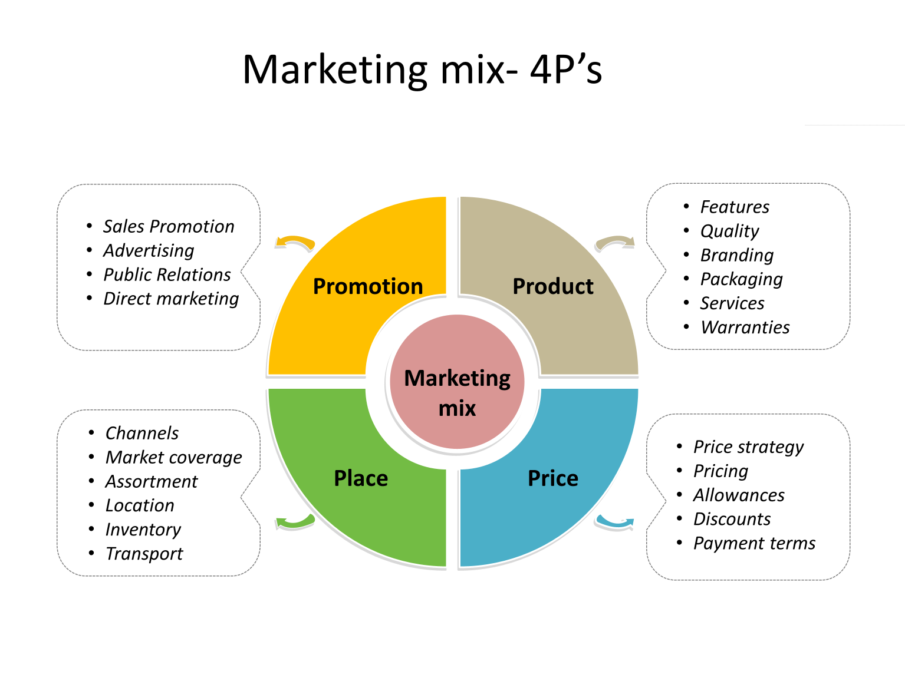**Product, price, place, and promotion are the Four Ps of marketing.** The Four Ps collectively make up the essential mix a company needs to market a product or service. Neil Borden popularized the idea of the marketing mix and the concept of the Four Ps in the 1950s.

**Product:**

Product refers to an item or items the business plans to offer to customers. The product should seek to fulfil an absence in the market, or fulfil consumer demand for a greater amount of a product already available. Before they can prepare an appropriate campaign, marketers need to understand what product is being sold, how it stands out from its competitors, whether the product can also be paired with a secondary product or product line, and whether there are substitute products in the market.

**Price:**

Price refers to how much the company will sell the product for. When establishing a price, companies must consider the unit cost price, marketing costs, and distribution expenses. Companies must also consider the price of competing products in the marketplace and whether their proposed price point is sufficient to represent a reasonable alternative for consumers.

**Place:**

Place refers to the distribution of the product. Key considerations include whether the company will sell the product through a physical storefront, online, or through both distribution channels. When it's sold in a storefront, what kind of physical product placement does it get? When it's sold online, what kind of digital product placement does it get?

**Promotion:**

Promotion, the fourth P, is the integrated marketing communications campaign. Promotion includes a variety of activities such as advertising, selling, sales promotions, public relations, direct marketing, sponsorship, and guerrilla marketing.

Promotions vary depending on what stage of the product life cycle the product is in. Marketers understand that consumers associate a product’s price and distribution with its quality, and they take this into account when devising the overall marketing strategy.

Advertising is an art not a science. Effectiveness of which can't be measured with a mathematical or empirical formula some advertisers argue that advertising efforts go to waste, but every advertiser is keenly interested in measuring or in evaluation of advertising effectiveness. Testing for the effectiveness of advertisement will lead advertisement testing must be done either before or after the advertisement has done in the media. It is of two types, protesting which are done before the advertisement has been launched and one is referred to as cost testing which is done before the advertisement has been launched and one is referred to as cost testing which is done after launching the advertising. The basic purpose of advertising effectiveness is to avoid costly mistakes, to predict the relative

Strength of alternative advertising strategies and to increase their efficiency. In measurement of advertisement effectiveness feedback is always useful level if it costs some extra expenditure to the advertiser.

The objectives of all business are to makes profits and a merchandising concern can do that by increasing its sales are moderative prices. This is possible, if the product is widely polished to be audience the final consumers, channel members and industrial users and through convincing arguments it is persuaded to buy it. Publicity makes a thing or an idea known to people. It is a general term indicating efforts at mass appeal. As personal stimulation of demand for a product service or business unit by planting commercially significant news about it in a published medium or obtaining favourable presentation of it upon video television or stage that is not paid for by the sponsor.

On the other hand, advertising denotes a specific attempt to popularize a specific product or service at a certain cost. It is a method of publicity. It always intentional openly sponsored by the sponsor and involves certain cost and hence is paid for. It is a common form of nonpersonal communication about an organization and or its product side a service etc. that is transmitted to a target audience through a mass medium. In common parlance the term publicity and advertising are used synonymously.

**What is advertising?**

The word ‘Advertising’ has its origin from a Latin word ‘Adventure’ which means to turn to. The dictionary meaning of the word is ‘to announce publicity or to give public concerned to a specific thing which has been announced by the advertiser publicity in order to inform and influence them with Reread them or pass them on to other. Some magazines have prestige value. The marketer can cover national or large regional markets at a low cost per contract (per individual reached). Magazines generally offer high-quality printing of advertisement. Simply stated advertising is the art "says green." Advertising is a general term for and all forms of publicity, from the cry of the street boy selling newspapers to the most celebrate attention attracts device. The object always is to bring to public notice some articles or service, to create a demand to stimulate buying and in general to bring together the man with something to sell and the man who has means or desires to buy".

Advertising has been defined by different experts. Some of the quoted definitions are:

American marketing association has defined advertising as: Any paid form of non-personal presentation and promotion of ideas, goods or services by an identified sponsor. The medium used are print broad cast and direct.

Stanton deserves that ―Advertising consists of all the activities involved in presenting to a group a non- personal, oral or visual openly, sponsored message regarding a product, service, or idea. This message called an advertisement is disseminated through one or more media and is paid for by the identified sponsor.

Advertising is any paid form of non–personal paid of presentation of ideas goods or services by an identified sponsor. Advertising is a “non- personal paid message of commercial significance about a product, service or company made to a market by an identified sponsor. In developing an advertising programme, one must always start by identifying the market needs and buyer motives and must make five major decisions commonly referred as 5M (mission, money message, media and measurement) of advertising.

**Basic Features of Advertising**

On the basis of various definitions, it has certain basic features such as:

* It is a mass non-personal communication.
* It is a matter of record.
* It persuades buyers to purchase the goods advertised.
* It is a mass paid communication.
* The communication media is diverse such as print (newspapers and magazines).

**Functions of Advertising**

For many firms advertising is the dominant element of the promotional mix – particulars for those manufacturers who produce convenience goods such as detergent, non – prescription drugs, cosmetics, soft drinks and grocery products. Advertising is also used extensively by maters of automobiles, home appliances, etc, to introduce new product and new product features it uses its attributes, pt availability etc.

Advertising can also help to convince potential buyers that a firm ‘s product or service is superior to competitor ‘s product in make in quality, in price etc. it can create brand image and reduce the likelihood of brand switching even when competitors lower their prices or offer some attractive incentives. Advertising is particularly effective in certain other spheres too such as:

* When consumer awareness of products or services is at a minimum.
* When sales are increasing for all terms in the industry.
* When a product is new and incorporates technological advances not strong.
* When a primary buying motive exists.

**Types of Advertising**

Broadly speaking, advertising may be classified into two categories viz., product and institutional advertising.

**Product Advertising:** The main purpose of such advertising is to inform and stimulate the market about the advertiser’s products of services and to sell these. Thus, type of advertising usually promotes specific, trended products in such a manner as to make the brands seam more desirable. It is used by business government organization and private non-business organizations to promote the uses features, images and benefits of their services and products. Product advertising is sub-divided into direct action and indirect action advertising, Direct action product advertising wages the buyer to take action at once, ice he seeks a quick response to the advertisement which may be to order the product by mail, or mailing a coupon, or he may promptly purchase in a retail store in response to prince reduction during clearance sale.

**Institutional Advertising:** It is designed to create a proper attitude towards the sellers to build company image or goodwill rather than to sell specific product or service. Its purpose is to create a frame of mind and to implant feeling favourable to the advertiser’s company. Its assignment is to make friends for the institution or organization. It is sub-divided into three categories: patronage, public, relations and public service institutional advertising.

In patronage institutional advertising the manufacturer tells his prospects and customer about himself his policies and lives personnel. The appeals to the patronage motivation of buyers. If successful, he convinces buyers that his operation entitles him to the money spent by them. Public relations institutional advertising is used to create a favorable image of the firm among employees, stock-holders or the general public. Public service institutional advertising wages public support.

**Other Types:** The other types are as follows:

Consumer advertising

Comparative advertising

Reminder advertising

Reinforcement advertising

**Guidelines for successful advertising campaigns**

Here are some guidelines for creating memorable advertising that really sells:

1. **Make sure your ads are "on strategy" with your business positioning:**

A good positioning strategy ensures identification of the correct target audience for your advertising, along with a listing of meaningful features and benefits. It can provide reasons why the product is superior and unique, along with an advertising "personality."

1. **Communicate a simple, single message:**

People have trouble remembering someone's name, let alone a complicated ad message. Use the "KISS" principle for ad messages: "Keep It Simple, Stupid." For print ads, the simpler the headline, the better. And every other ad element should support the headline message, whether that message is "price," "selection," "quality," or any other single-minded concept.

1. **Stick with a likable style:**

Ads have personality and style. The Pillsbury Doughboy becomes a beloved icon; the Quiznos "sponge monkeys" nearly sunk the brand. Find a likable style and personality and stay with it for at least a year or more of ads. Changing ad styles and personality too often will confuse potential buyers. It also fights against memorability.

1. **Be credible:**

If you say your quality or value is the "best" and it is clearly not, advertising will speed your demise, not increase your business. Identifying and denigrating the competition should also be avoided. It is potentially confusing and distracting and may back fire on you by making buyers more loyal to competitive products, not less.

1. **Ask for the sale:**

Invite buyers to come to your store, send for more information, or call for information and orders in the ad. Provide easily visible information in the ad for potential customers to buy: location, telephone number, store hours, charge cards accepted, etc.

1. **Make sure the ad is competitive:**

Do your homework. Examine competitive ads in the media that you are planning to advertise in. Make sure your ad stands out from competitive ads. You can use personal judgment, ad test exposures to a small group of target buyers (i.e., qualitative research), or more expensive, sophisticated quantitative test methods. Compare ads for uniqueness, memorability, credibility, and incentive to purchase.

1. **Make sure the ad looks professional:**

If you have the time and talent, computer graphics and desktop publishing software can provide professional-looking templates to create good-looking print ads. Consider obtaining writing, artistic, and graphics help from local agencies or art studios who have experienced professionals on staff, with expensive and creative computer software in-house. They may save you time and money in the long run, with better results. Electronic ads (e.g., TV, radio, Internet) and outdoor ads are best left to professionals to write, produce, and buy for a fee or percentage of media dollars spent (i.e., generally 15 percent of gross media spending).

1. **Be truthful:**

Whatever advertising medium you select, make sure your message is ethical and truthful. There are stringent laws regarding deceptive practices and false advertising.

**1.2 INDUSTRY PROFILE**

Soft drink, any of a class of non-alcoholic beverages, usually but not necessarily carbonated, normally containing a natural or artificial sweetening agent, edible acids, natural or artificial flavours, and sometimes juice. Natural flavours are derived from fruits, nuts, berries, roots, herbs, and other plant sources. Coffee, tea, milk, cocoa, and undiluted fruit and vegetable juices are not considered soft drinks.

The term soft drink was originated to distinguish the flavoured drinks from hard liquor, or distilled spirits. Soft drinks were recommended as a substitute in the effort to change the hard-drinking habits of early Americans. Indeed, health concerns of modern consumers led to new categories of soft drinks emphasizing low calorie count, low sodium content, no caffeine, and “all natural” ingredients.

There are many specialties soft drinks. Mineral waters are very popular in Europe and Latin America. Kava, made from roots of a bushy shrub, Piper methysticum, is consumed by the people of Fiji and other Pacific islands. In Cuba people enjoy a carbonated cane juice; its flavour comes from unrefined syrup. In tropical areas, where diets frequently lack sufficient protein, soft drinks containing soybean flour have been marketed. In Egypt carob (locust bean) extract is used. In Brazil a soft drink is made using maté as a base. The whey obtained from making buffalo cheese is carbonated and consumed as a soft drink in North Africa. Some eastern Europeans enjoy a drink prepared from fermented stale bread. Honey and orange juice go into a popular drink of Israel.

The first marketed soft drinks appeared in the 17th century as a mixture of water and lemon juice sweetened with honey. In 1676 the Compagnie de Limonadiers was formed in Paris and granted a monopoly for the sale of its products. Vendors carried tanks on their backs from which they dispensed cups of lemonade.

Carbonated beverages and waters were developed from European attempts in the 17th century to imitate the popular and naturally effervescent waters of famous springs, with primary interest in their reputed therapeutic values. The effervescent feature of the waters was recognized early as most important. Flemish scientist Jan Baptista van Helmont first used the term gas in his reference to the carbon dioxide content. French physician Gabriel Venel referred to aerated water, confusing the gas with ordinary air. British scientist Joseph Black named the gaseous constituent fixed air.

Robert Boyle, an Anglo-Irish philosopher and scientist who helped found modern chemistry, published his Short Memoirs for the Natural Experimental History of Mineral Waters in 1685. It included sections on examining mineral springs, on the properties of the water, on its effects upon the human body, and, lastly, “of the imitation of natural medicinal waters by chemical and other artificial ways.”

Numerous reports of experiments and investigations were included in the Philosophical Transactions of the Royal Society of London in the late 1700s, including the studies of Stephen Hales, Joseph Black, David MacBride, William Brownrigg, Henry Cavendish, and Thomas Lane.

English clergyman and scientist Joseph Priestley is nicknamed “the father of the soft drinks industry” for his experiments on gas obtained from the fermenting vats of a brewery. In 1772 he demonstrated a small carbonating apparatus to the College of Physicians in London, suggesting that, with the aid of a pump, water might be more highly impregnated with fixed air. French chemist Antoine-Laurent Lavoisier made the same suggestion in 1773.

To Thomas Henry, an apothecary in Manchester, England, is attributed the first production of carbonated water, which he made in 12-gallon barrels using an apparatus based on Priestley’s design. Swiss jeweler Jacob Schweppe read the papers of Priestley and Lavoisier and determined to make a similar device. By 1794 he was selling his highly carbonated artificial mineral waters to his friends in Geneva; later he started a business in London.

At first, bottled waters were used medicinally, as evidenced in a letter written by English industrialist Matthew Boulton to philosopher Erasmus Darwin in 1794: By about 1820, improvements in manufacturing processes allowed a much greater output, and bottled water became popular. Mineral salts and flavours were added—ginger about 1820, lemon in the 1830s, tonic in 1858. In 1886 John Pemberton, a pharmacist in Atlanta, Georgia, invented Coca-Cola, the first cola drink.

Now, the soft drink industry has been dominated by three major player – (1) The New York based Pepsi co. Inc. (2) The Atlanta based Coca Cola co. (3) The United Kingdom based Cadbury Schweppes.

Throughout the globe these major players have been battling it. Out for a bigger chunk of the ever-growing cold drink market. Now this battle has begun in India too. India is now the part of cold drink war. Gone are days of Ramesh Chauhan, India’s one time Cola king and his bouts of pistol shooting. Expect now to hear the boon of cannons when the Coca Cola & Pepsi co. battle it out for, as the Jordon goes a bigger share of throat. By buying over local competition, the two American Cola giants have cleared up the arena and are packing all their power behind building the Indian franchisee of their globe girdling brands. The huge amount invested in fracture has never been seen before. Both players seen an enormous potential in his country where swigging a carbonated beverage is still considered a treat, virtually a luxury. Consequently, by world standards India’s per capita consumption of cold drinks as going by survey results is rock bottom, less than over Neighbours Pakistan & Bangladesh, where it is four times as much.

Behind the hype, in an effort invisible to consumer Pepsi pumps in Rs 3000 crores (1994) to add muscle to its infrastructure in bottling and distribution. This is apart from money that company’s franchised bottles spend in upgrading their plants all this has contributed to substantial gains in the market. In Colas, Pepsi is already market leader and in certain cities like Banaras, Pepsi outlets are on one side & all the other Colas put together on the other. While Coke executive scruff at Pepsi’s claims as well as targets, industry observers are of the view that Pepsi has definitely stolen a lot from its competitor Coke.

The soft drink industry is growing now at 6 to 7% annually. In India, Coke and Pepsi have a combined market share of around 95% directly or through franchisees. Campa Cola has a 1% share, and the rest is divided among local players. Industry watchers say, fake products also account for a good share of the balance. There are about 110 soft drink producing units (60% being owned by Indian bottlers) in the country, employing about 125,000 people. There are two distinct segments of the market, cola and non-cola drinks. The cola segment claims a share of 62%, while the non-cola segment includes soda, clear lime, cloudy lime and drinks with orange and mango flavours.

The per capita consumption of soft drinks in India is around 5 to 6 bottles (same as Nepal's) compared to Pakistan's 17 bottles, Sri Lanka's 21, Thailand's 73, the Philippines 173 and Mexico 605. The industry contributes over Rs 12 bn to the exchequer and exports goods worth Rs 2 bn. It also supports growth of industries like glass, refrigeration, transportation, paper and sugar. The Department of Food Processing Industries had stipulated that 'contains-no-fruit-juice' labels be pasted on returnable glass bottles. About 85% of the soft drinks are currently sold in returnable bottles. There was a floating stock of about 1000 mn bottles valued at Rs 6 bn. If the industry were to abide by the new guidelines, it would have to invest in new bottles, resulting in a cost outgo of Rs 5 bn. Neither Coke nor Pepsi is in a position to invest such a large amount.

Around 400,000 tonnes of raw material would be required to replace the existing stock of bottles. Instead, the soft drink industry suggested that a seven-year moratorium be extended to the industry so that it can incorporate the change in a phased manner. There is no such mandatory requirement anywhere in the world to specifically label the glass surface of returnable bottles. The government has decided to extend the date for replacing the bottles to end-march 2006. In the meantime, the producers have shifted substantially to the use of PET bottles.

Soft and aerated drinks were considered products for the middle class and the affluent. That segregation is no more valid. Soft and aerated drinks are consumed by all except those who cannot afford to buy any drink. An NCAER study says that 91% soft drink sales are made to the lower, middle and upper middle classes. The soft drink industry has been urging the government to categorise aerated waters (soft drinks) equitably with other consumer products of mass consumption and remove special excise duty.

The industry estimates that the beverage market should grow at twice the rate of GDP growth. The Indian market should have, therefore, grown by at least 12%. However, it has been growing at a rate of about 6%. In contrast, the Chinese market grew by 16% a year, while the Russian market expanded at almost four times the rate of growth of the Indian market.

It may be recalled that Coca-Cola, the world's number one player, was present in India for a long time in collaboration with an Indian producer but was thrown out in the late 1970s. It reappeared in India following the economic liberalization era - but after its rival, world's number two, had already entered in a big way following a long and tough fight against the opposition from the domestic producers. When Coca-Cola re-entered, it installed a new milestone. It acquired the well flourishing India's top player, Parle. Since then, it is basically a fight between the two American giants. Others are playing a peripheral role, as adjuncts to the two MNCs. World's third biggest player, Cadbury Schweppes, had also made an entry but was gobbled up by Coca-Cola. When Coca-Cola acquired Parle brands, it was, in fact, buying the bottling facilities, the marketing network, and the established consumer preference during the market build-up. The brands were a drag on the global brand. Since Coca-Cola was not interested in brands (like Thumps Up), it did not promote them. The result, at least, in the short run was a loss of the market to the competitor. Coca-Cola decided to market more effectively the Parle brands. It had in its armoury Coke, Thumps Up, Limca and Fanta. The latest to enter market was Parle’s erstwhile Rimzim, alongside Portello, a black currant flavoured drink, very popular in Sri Lanka.

Coca-Cola operates through 35 plants and 16 franchisees throughout the country, while PepsiCo has 20 plants, but it has 7 more franchisees at 23 to 16 of its rival. Coca-Cola claims a market share of 51%, while Pepsi has a share of 46%. The claims, however, remain disputed. The other smaller players like Pure Drinks Ltd claim the rest of the market. The shares of the two lead players are consolidated figures, which include the respective bottlers. Coca-Cola had approached the government for a five-year extension for divesting 49% equity in its bottling subsidiary, Hindustan Coca-Cola Holdings. It had set up the marketing subsidiary as part of its strategy to integrate all its bottling operations, both company-owned and franchisee bottlers, apparently keeping in line with its global policy. Altogether, it had bought initially over 38 franchisee bottlers.

Kandhari Beverages, coke bottlers for north have been eyeing to lift a stake in Coca-Cola India. Coca-Cola had filed an application to offload 49% stake of its bottling operations in favour of their Indian operators. Besides Kandhari, three other bottlers, one each from Uttar Pradesh, Gujarat and Jammu, were lined up to invest in Hindustan Coca-Cola Holding. Kandhari has already invested Rs 300 mn in 1999 and 2020 to upgrade its capacity. The total investment by all the four was expected to be Rs 1000 mn. Both Coca-Cola and PepsiCo planned for the launch of lemon-flavored versions of their products. Both have been expanding their non-carbonated drink line-ups, as consumers seem to be shifting away from carbonated soft drinks. PepsiCo is deliberating whether to come out with Pepsi Twist, a cola mixed with lemon. But while both companies have juice sports drinks, bottled water and other such drinks in their line-ups, neither coke nor Pepsi has launched a new national variety of a cola-flavoured carbonated soft drink in years.

PepsiCo had achieved Rs 3 bn worth of exports, which include processed foods, basmati rice, guar gum and soft drinks concentrate. PepsiCo completed the second phase of its expansion and with this expansion, PepsiCo was to explore the possibility of expanding the export of concentrates to more countries in addition to the exports to Russia and other South Asian countries.

Pepsi India has entered into a marketing tie up with Hindustan Lever to promote sales of soft drinks through Pepsi-HLL network of vending machines and fountains. The major soft drink brands in the Pepsi stable are Pepsi, 7UP, Mirinda, Tropicana and Acquafina.

As a major strategic departure, both MNCs were expanding their brand range. Consequent to some diversifying moves, at present, the sales ratio of Coca-Cola between soft drinks and other beverages is 95.5. The company intended to change this to 80:20 in the next three years. Its juice brand, Maaza - acquired from Parle a few years ago - is being given a major thrust. It has plans to go in for canned coffee, iced tea and purified categories under expansion schemes. It has already launched its bottled water brand, Kinley, in the Indian market. Besides, it is intending to acquire domestic brands in the non-carbonated beverages segment.

The global deal between Coca-Cola and P&G to form a snacks and beverages joint venture company was reported to have slipped into rough weather. The P&G brand of potato wafer, Pringles, seemed to be faced with distribution problems in India. P&G had globally tied up with Coca-Cola to form a stand-alone juice and snacks company. The new firm is focused on developing and marketing new juices, juice-based beverages and snacks on a global basis. The Sharjah-based Allied Beverages was pushing its Ahlan brand in India, having entered the market in mid-2000. Its target was carbonated drinks market in PET bottles. Its plans were to launch a PET bottle in the popular 300 ml category. Ahlan expected to gain a 12% share of the total PET bottle market in northern India. Of the total market, PET bottle segment is approximately 12%. Presently, Allied Beverages has a manufacturing unit at Dharuhera in Haryana. The product range includes carbonated drinks - cola, orange, lemon and soda in three pack sizes - 500 ml, 1500 ml and 2000 ml. Allied Beverages sells non-carbonated drinks in 200 ml food grade cups priced at Rs 7 in its portfolio, available in four different flavours. The company's future plans include pulp-based fruit drinks in flavours, which will be available in 200 ml non-returnable glass bottles.

**Carbonated soft drink in India**

* Revenue in the Soft Drinks segment amounts to US$3.36bn in 2022. The market is expected to grow annually by 4.18% (CAGR 2022-2026).
* In global comparison, most revenue is generated in the United States (US$318.50bn in 2022).
* In relation to total population figures, per person revenues of US$2.39 are generated in 2022.
* By 2026, 7% of spending and 2% of volume consumption in the Soft Drinks segment will be attributable to out-of-home consumption (e.g., in bars and restaurants).
* In the Soft Drinks segment, volume is expected to amount to 6,255.2ML by 2026. The Soft Drinks segment is expected to show a volume growth of 2.4% in 2023.
* The average volume per person in the Soft Drinks segment is expected to amount to 3.91 L in 2022.

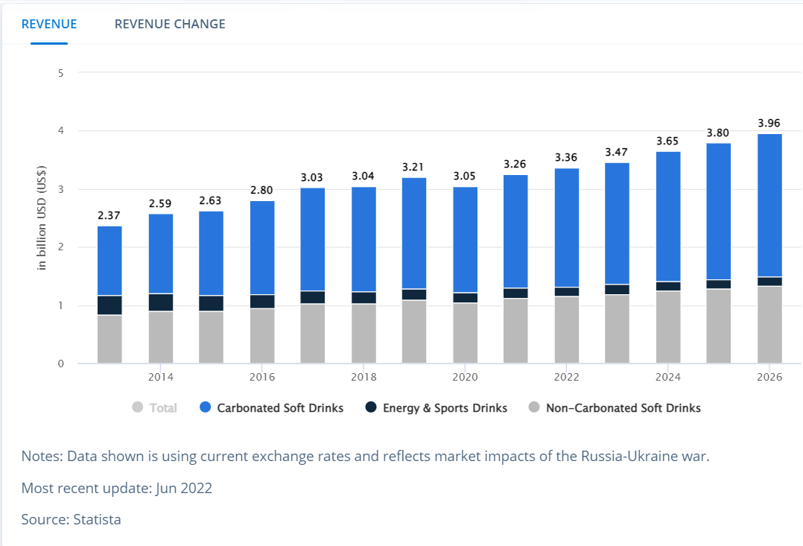

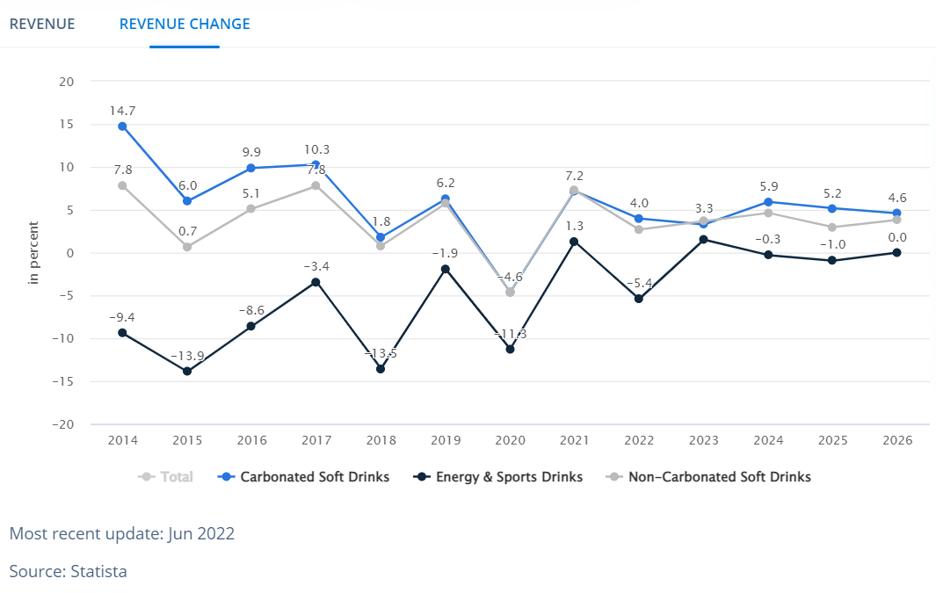

**Analyst opinion**

Soft drinks are the biggest pillar on which the business of non-alcoholic drinks rests. The biggest players in the field – Coca Cola and PepsiCo – are, at their core, soft drink manufacturers. Business-wise, the segment is characterized by multinational brand players that mainly focus on product development and marketing and by regional bottlers that license their brands for distribution in selected areas. Strategically, the industry has witnessed both a trend towards streamlining operations as well as a hunt for novel products which could fill a niche.

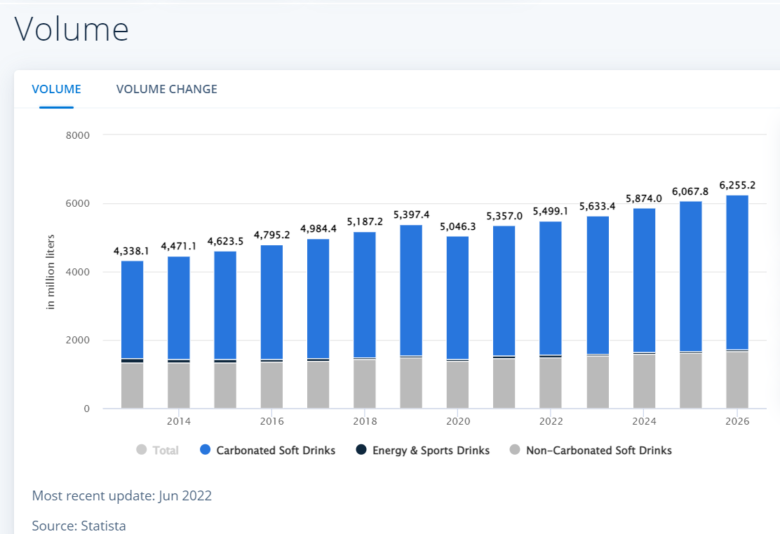

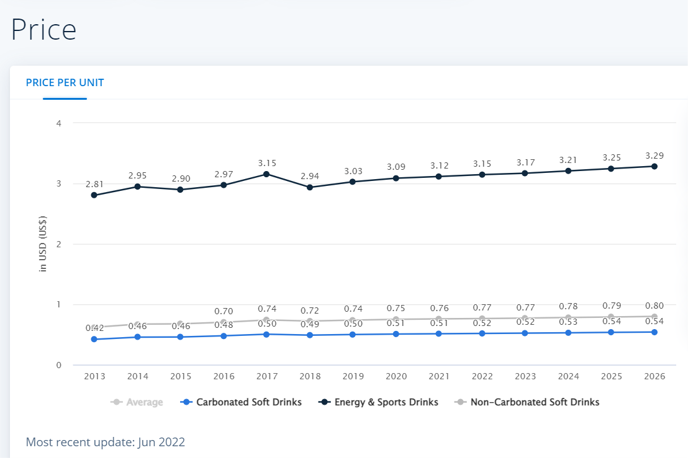

**Challenges faced by Beverage Industry**

Despite being the second highest producer of beverage, India is yet to evolve extensively when it comes to food and beverage industry. This industry is made up of an array of products including alcoholic drinks, juice/health, alcoholic and aerated drinks. Beverages are currently receiving substantial attention as their market potential is mushrooming. The soft drink and alcohol industry had made significant progress during last several years in production.

Although, still the level of processing is lower in contrast to other countries. It takes double the time as compared to other countries to the get the process and regulations done. The beverage industry presents absolute challenges to each of the stakeholder community. The challenge to the industry is how effectively beverages can be developed in the marketplace. To the consumer, the call out is whether to trust the experts and if so what is the proposed benefits of beverages. The challenge of the government bodies is how to maintain a balance in preventing false and misleading information from reaching consumers while reassuring the use of beverages to attain a healthy lifestyle. So, some of the hindrances that this industry faces massively are:

1. **Upswing of Healthy and Organic Drinks:**

While packaged drinks were once at the peak of the supply chain, but this trend does not hold true anymore. Currently, consumers are looking out for drinks that do not contain synthetic ingredients. The drastic reduction in the demand for processed drinks have nourished the organic market and caused many hitches in the beverage market and competition. Growing awareness levels regarding natural, healthy drinks and their practical impacts have favoured the trade for natural beverages. Industry Hercules needs to brainstorm multiple channels to combat the biggest challenge that healthy drinks will become in the upcoming future.

1. **Complicated Government Regulations:**

This sector is continuously monitored by reforms and regulations. New tax regime under GST discourages aerated beverage and other drink consumption. One of the major challenges that this industry faces is the complicated and overlapping taxation structure in India. Specifically in beer market, the biggest drawback is that every state has different set of regulations. It feels like you are operating with 28 diverse countries.

1. **Environment Friendly Propaganda:**

Environment-friendly is the next leading trend in the Indian market, owing to global warming and other weather conditions. A product that is tagged to be “eco-friendly” obviously has more chances of a fruitful sale than a product that is assumed to be harmful to the environment. The beverage companies are striving hard in making the entire manufacturing process friendlier to the environment, by maintaining reprocessing practices and profiting from renewable sources of energy. Exercising green business practices is a vital part of the few challenges in food and beverage industry in India.

1. **The E-commerce Edge:**

This sector has been relatively slow on the upkeep of technology, while industries like electronics, textiles, and other domestic products have already ingrained their presence in the commerce domain. This is one of the extreme challenges in beverage industry, considering that consumers are more technologically attentive and sociable, thanks to the invention of internet and social media. Wholesalers and retail industries have already begun to invest in e-commerce and Instagram, Facebook to develop reach of their products. This is causing a huge flood in the beverage sector and worry about further diversification.

1. **Dearth of Innovation:**

Innovation is among the top challenges in beverage industry today. To combat intense competition, manufacturers must come up with inventive products. In Indian market, all we see is: pool of products that are generally of the same character and term. For example, there is a wave of organic things; so people will follow the similar footsteps rather than going and bending the monotony. The challenge of innovation is surely a roadblock in the Indian scenario.

1. **Logistics:**

The logistics market in India is highly unorganized with plenty national level players in the beverage sector. The infrastructure is grossly inadequate, with lack of proper roads and networks. Insufficient distribution channels, exploited ports, and poor quality of services are just a few of the bottlenecks that imprint beverage players and their production. This leads to high logistics costs, which leads to higher cost of pre-production as compared to other countries.

To conclude, the challenges in food and beverage industry are immense, owing to the massive competition. A single transformation is constrained to affect the entire supply chain. Contemporary markets, changing consumer spending, increasing prices due to taxes, universal appetite, and modern technology are predicted to bring about extensive changes in this sector in the next coming years. Despite the ongoing challenges in beverage industry, it is anticipated to show beneficial gains in the near future.

**Key players of Beverage industry**

1. Varun Beverages
2. Dabur India Ltd
3. Orient Beverage Limited
4. Red Bull India Pvt Ltd
5. Tetra Pak India Pvt Ltd
6. Pearl Drinks Ltd
7. Bengal Beverages Ltd
8. Coca-Cola India
9. PepsiCo India holdings
10. Enkay Texofood Industries Limited

**1.3 COMPANY PROFILE**

Coca-Cola began serving a delicious and refreshing sparkling beverage 125 years ago in Atlanta, Georgia. With that first moment of refreshment came a thirst for more that continues to this day. We now have more than 500 brands and 3,500 beverage products and sell 1.7 billion servings per day in over 200 countries.

Coca-Cola, the product that has given the world its best-known taste was born in Atlanta, Georgia, on May 8, 1886. Coca-Cola Company is the world’s leading manufacturer, marketer and distributor of non-alcoholic beverages, concentrates and syrups produce nearly 500 beverage brands. It sells beverage concentrates and syrups to bottling and canning operators, distributors, fountain retailers and fountain wholesalers.

The Company’s beverage products comprise of bottled and canned soft drinks as well as concentrates, syrups and not-ready-to-drink powder products. In addition to this, it also produces and markets sports drinks, tea and coffee. The Coca-Cola Company began building its global network in the 1920s. Now operating in more than 200 countries and producing nearly 500 brands, the Coca-Cola system has successfully applied a simple formula on a global scale: “Provide a moment of refreshment for a small amount of money- a billion times a day.” The Coca-Cola Company and its network of bottlers comprise the most sophisticated and pervasive production and distribution system in the world.

More than anything, that system is dedicated to people working long and hard to sell the products manufactured by the Company. This unique worldwide system has made the Coca- Cola Company the world’s premier soft-drink enterprise. From Boston to Beijing, from Montreal to Moscow, Coca-Cola, more than any other consumer product, has brought pleasure to thirsty consumers around the globe. For more than 125 years, Coca-Cola has created a special moment of pleasure for hundreds of millions of people every day.

The Company aims at increasing shareowner value over time. It accomplishes this by working with its business partners to deliver satisfaction and value to consumers through a worldwide system of superior brands and services, thus increasing brand equity on a global basis. They aim at managing their business well with people who are strongly committed to the Company values and culture and providing an appropriately controlled environment, to meet business goals and objectives. The associates of this Company jointly take responsibility to ensure compliance with the framework of policies and protect the Company’s assets and resources whilst limiting business risks.

Coca-Cola was first introduced by John Syth Pemberton, a pharmacist, in the year 1886 in Atlanta, Georgia when he concocted caramel-coloured syrup in a three-legged brass kettle in his backyard. He first “distributed” the product by carrying it in a jug down the street to Jacob’s Pharmacy and customers bought the drink for five cents at the soda fountain. Carbonated water was teamed with the new syrup, whether by accident or otherwise, producing a drink that was proclaimed “delicious and refreshing”, a theme that continues to echo today wherever Coca-Cola is enjoyed.

Dr. Pemberton’s partner and book-keeper, Frank M. Robinson, suggested the name and penned “Coca-Cola” in the unique flowing script that is famous worldwide even today. He suggested that “the two Cs would look well in advertising.” The first newspaper ad for Coca-Cola soon appeared in The Atlanta Journal, inviting thirsty citizens to try “the new and popular soda fountain drink.” Hand-painted oil cloth signs reading “Coca-Cola” appeared on store awnings, with the suggestions “Drink” added to inform passers-by that the new beverage was for soda fountain refreshment.

By the year 1886, sales of Coca-Cola averaged nine drinks per day. The first year, Dr. Pemberton sold 25 gallons of syrup, shipped in bright red wooden kegs. Red has been a distinctive color associated with the soft drink ever since. For his efforts, Dr. Pemberton grossed $50 and spent $73.96 on advertising. Dr. Pemberton never realized the potential of the beverage he created. He gradually sold portions of his business to various partners and, just prior to his death in 1888, sold his remaining interest in Coca-Cola to Asa G. Candler, an entrepreneur from Atlanta. By the year 1891, Mr. Candler proceeded to buy additional rights and acquire complete ownership and control of the Coca-Cola business. Within four years, his merchandising flair had helped expand.

Consumption of Coca-Cola to every state and territory after which he liquidated his pharmaceutical business and focused his full attention on the soft drink. With his brother, John S. Candler, John Pemberton’s former partner Frank Robinson and two other associates, Mr. Candler formed a Georgia corporation named the Coca-Cola Company. The trademark “Coca-Cola,” used in the marketplace since 1886, was registered in the United States Patent Office on January 31, 1893.

The business continued to grow, and in 1894, the first syrup manufacturing plant outside Atlanta was opened in Dallas, Texas. Others were opened in Chicago, Illinois, and Los Angeles, California, the following year. In 1895, three years after The Coca-Cola Company’s incorporation, Mr. Candler announced in his annual report to share owners that “Coca-Cola is now drunk in every state and territory in the United States.”

As demand for Coca-Cola increased, the Company quickly outgrew its facilities. A new building erected in 1898 was the first headquarters building devoted exclusively to the production of syrup and the management of the business. In the year 1919, the Coca-Cola Company was sold to a group of investors for $25 million. Robert W. Woodruff became the President of the Company in the year 1923 and his more than sixty years of leadership took the business to unsurpassed heights of commercial success, making Coca-Cola one of the most recognized and valued brands around the world.

**MISSION, VISION AND VALUES**

The world is changing all around us. To continue to thrive as a business over the next ten years and beyond, we must look ahead, understand the trends and forces that will shape our business in the future and move swiftly to prepare for what's to come. We must get ready for tomorrow today. That's what our 2020 Vision is all about. It creates a long-term destination for our business and provides us with a "Road map" for winning together with our bottling partners.

**Mission**

Road map starts with mission, which is enduring. It declares purpose as a Company and serves as the standard against which we weigh our actions and decisions.

* To refresh the world in mind, body and spirit.
* To inspire moments of optimism and happiness through our brands and actions.
* To create value and make a difference.

**Vision**

vision is to craft the brands and choice of drinks that people love, to refresh them in body & spirit. And done in ways that create a more sustainable business and better shared future that makes a difference in people’s lives, communities and our planet.

**Awards:**

* HCCB factories at Sanand and Goblej win gold award at the India Green Manufacturing Challenge-2021
* Hindustan Coca-Cola Beverage factory at Sanand, bags ‘Future Ready Factory of the Year – Platinum’ Award-2020
* CII felicitates the Hindustan Coca-Cola Beverages factory at Bidadi for its food safety practices-2020
* HCCB receives a rare recognition from Metro Cash and Carry-2020
* HCCB wins the Corporate Governance Excellence Award-2020
* NASSCOM Confers “Transformation Catalyst” Award To HCCB-2019
* HCCB wins the "Best in Procurement Innovation Award" at the CPO Innovation - Tech Supply Chain Innovation Awards 2019 in Bengaluru-2019
* HCCB wins the Best 50 PCI Companies for 2019

**Size of the cold drinks available in market:**

* 250 ml Bottles
* 300 ml Bottles
* 500 ml Bottles
* 600 ml Bottles
* 750 ml Bottles
* 1Litre
* 1.5 Liter
* 2 Liter

**Beverages Categories:**

1. Sparkling
2. Hydration
3. Juices
4. Tea & coffee



**Sparkling products:**

* Coca-Cola
* Thums up
* Fanta
* Sprite
* Limca
* Rimzim

**Hydration products:**

* Kinley
* Smart water

**Juices product:**

* Minute maid
* Maaza
* Rani

**Tea & coffee:**

* Georgia
* Costa coffee

**HINDUSTAN COCA-COLA COMPETITORS:**

* Red Bull,
* Tetra Pak,
* Keurig Dr Pepper,
* PepsiCo and Soylent

**Coca-Cola Reports First Quarter 2022 Results**

Global Unit Case Volume Grew 8%

Net Revenues Grew 16%;

Organic Revenues (Non-GAAP) Grew 18%

Operating Income Grew 25%; Comparable Currency Neutral Operating Income (Non-GAAP) Grew 24%

Operating Margin Was 32.5% Versus 30.2% in the Prior Year; Comparable Operating Margin (Non-GAAP) Was 31.4% Versus 31.0% in the Prior Year

EPS Grew 23% to $0.64; Comparable EPS (Non-GAAP) Grew 16% to $0.64

ATLANTA, April 25, 2022: The Coca-Cola Company today reported first quarter 2022 results, showing continued momentum in our marketplace performance. “We are pleased with our first quarter results as our company continues to execute effectively in a highly dynamic and uncertain operating environment,” said James Quincey, Chairman and CEO of The Coca-Cola Company. “We remain true to our purpose and are staying close to consumers. We are confident in our full-year guidance, and we are well-equipped to win in all types of environments as we fuel strong top line momentum and create value for our stakeholders.”

**Highlights**

**Quarterly / Full-Year Performance**

**Revenues:** Net revenues grew 16% to $10.5 billion, and organic revenues (non-GAAP) grew 18%. Revenue performance included 7% growth in price/mix and 11% growth in concentrate sales. Concentrate sales were 3 points ahead of unit case volume, largely due to the timing of concentrate shipments in the current quarter, partially offset by the impact of one less day in the quarter.

**Margin:** Operating margin, which included items impacting comparability, was 32.5% versus 30.2% in the prior year, while comparable operating margin (non-GAAP) was 31.4% versus 31.0% in the prior year. Operating margin expansion was primarily driven by strong top line growth, partially offset by an increase in marketing investments versus the prior year, the impact of the BODYARMOR acquisition and currency headwinds.

**Earnings per share:** EPS grew 23% to $0.64, and comparable EPS (non-GAAP) grew 16% to $0.64. Comparable EPS (non-GAAP) performance included the impact of an 8-point currency headwind.

**Market share:** The company gained value share in total non-alcoholic ready-to-drink (NARTD) beverages, which included share gains in both at-home and away-from-home channels.

**Cash flow:** Cash flow from operations was approximately $620 million, a decline of $1.0 billion versus the prior year, as strong business performance was more than offset by the impact of cycling the timing of working capital benefits in the prior year and higher 2021 annual incentives in the current year. Free cash flow (non-GAAP) was approximately $400 million, a decline of $1.0 billion versus the prior year.

**2. RESEARCH METHODOLOGY**

**2.1 NEED OF THE STUDY**

Need to doing the study on advertising effectiveness is whether the Advertising campaign was successful or not, the awareness level of products, the advertising campaign increased the customer base or not and which media carry the advertisement successfully. The need of the study is conducted only for organization level. It is to understand how advertisement effects on: To getting market stage, to producing products, to creation of demand and supply.

**2.2 Problem definition**

To study effectiveness advertising of Hindustan coca cola beverages pvt ltd.

**2.3 Study objectives**

1. To know the most effective media of advertisement using by Hindustan Coca-Cola beverages pvt ltd.
2. To find out the reasons for liking the advertisement of Hindustan Coca-Cola beverages pvt ltd.
3. To find out the most popular slogan of advertisement of Hindustan Coca-Cola beverages pvt ltd.

**2.4 Hypothesis**

HA- There is no significance relation between advertising and sales.

Ho- There is significance relation between advertising and sales.

**2.5 Scope of the study**

To know the impact of advertisement on its customer, to know which source of advertisement that suits the organization, to know customers perception towards advertisement strategy implemented.

**2.6 Research design**

The research design is the blueprint for the fulfilment of objectives and answering questions. It is a master plan specifying the method and procedures for collecting and analysing needed information. Descriptive Research is used in this study as the main aim is to describe characteristics of the phenomenon or a situation.

**2.7 Data Sources**

The source of data includes primary and secondary data sources.

**Primary Sources:** Primary data has been collected directly from sample respondents through questionnaire and with the help of interview.

**Secondary Sources:** Secondary data has been collected from standard textbooks, Newspapers, Magazines & Internet.

**2.8 Sample Design**

Sample design is definite plan determine before any data is actually obtaining a sample from a given population. The researcher must decide the way of selecting a sample. Samples can be either probability samples or non-probability samples.

**2.8.1 Sampling Method**

Simple random sampling was used for selecting the sample method.

**2.8.2 Sample Size**

sample sizes of 120 respondents were selected for the purpose of the study.

**2.8.3 Sample population:**

300

**2.8.4 Sampling unit**

Company name: Hindustan coca cola beverages pvt ltd

Location: Srikalahasti

**2.9 Tools of analysis**

The data collected through survey have been carefully, meaningfully analysed by well - established statistical tools like,

• Simple percentage method

• Chi-square test

* **Simple percentage method**

The percentage method was used to get the percentage for the tabulated data by the calculated the analysis and interpretation has done by the type of information, which is collected by me.

No. of Respondents

Percentage = ------------------------------- X 100

Total No. Of Respondents

* **Chi-square test**

A test that uses the chi-square statistic to test the fit between a theoretical frequency distribution and a frequency distribution of observed data for which each observation may fall into one of several classes.



Where 0i= observed frequencies at I, j

Ei= Expected frequencies at I, j

r= number of rows

e= number of columns

X^2 calculated ≤ x^2 table, accept the null hypothesis H0.

Criterion for acceptance or rejection: If the calculated chi-square value is greater than the table value, the null hypothesis is accepted. If the calculated chi-square value is less than the table value, the null hypothesis is rejected.

**2.10 Limitations of the study**

* As the time given for the completion of the project was limited.
* There may be error due to bias of respondents.
* Lack of customer's cooperation was a major constraint.
* Majority of the customer were too aggressive in nature.
* The sample was restricted to 120 customers, which may restrict the scope and completion of study.

**2.11 chapterization**

Chapter-1: It deals with the Introduction, Industry Profile and Company Profile.

Chapter-2: It deals with the Research Methodology and Objectives of the Study.

Chapter-3: It deals with the data analysis and interpretation.

Chapter-4: It deals with the findings, suggestions and conclusion.

Appendix: It deals with the bibliography and questionnaire.

**3.Data analysis and interpretation**

**3.1 Representing gender of respondent**

**3.1 Table: Table representing gender of respondent**

|  |  |  |  |
| --- | --- | --- | --- |
| **S.NO** | **GENDER** | **FREQUENCY** | **PERCENTAGE** |
| 1 | Male | 70 | 58 |
| 2 | Female | 50 | 42 |
| 3 | Total | 120 | 100 |

**3.1 Table: Graph representing gender of respondent**

**Interpretation:**

From above table 3.1, it’s observed that out of 120 respondents 70 male (i.e.,58%) and 50 females (i.e.,42%) respondents respectively.

**3.2 Representing Age of respondent**

**3.2 Table: Table representing Age of respondent**

|  |  |  |  |
| --- | --- | --- | --- |
| **S.NO** | **Age (In years)** | **Frequency** | **PERCENTAGE** |
| 1 | 15-20 | 55 | 46 |
| 2 | 21-35 | 40 | 33 |
| 3 | 36-45 | 15 | 13 |
| 4 | 45 above | 10 | 8 |
| 5 | Total | 120 | 100 |

**3.2 Graph: Graph representing Age of respondent**

**Interpretation:**

From above table 3.2, it’s observed that out of 120 respondents- 55 respondents are in age 15-20 (i.e.,46%), 40 respondents are in age 21-35 (i.e.,33%), 15 respondents are in age 36-45 (i.e.,13%), 10 respondents are in age 45 above (i.e.,8%).

**3.3 Representing Occupation of respondent**

**3.3 Table: Table representing Occupation of respondent**

|  |  |  |  |
| --- | --- | --- | --- |
| **S.NO** | **Occupation** | **Frequency** | **Percentage** |
| 1 | Student | 45 | 38 |
| 2 | Employee | 35 | 29 |
| 3 | Housewife | 10 | 8 |
| 4 | Other | 30 | 25 |
| 5 | Total | 120 | 100 |

**3.3 Table: Table representing Occupation of respondent**

**Interpretation:**

From above table 3.3, it’s observed that out of 120 respondents- 45 respondents are students (i.e.,38%), 35 respondents are employee (i.e.,29%), 10 respondents are housewife’s (i.e.,8%), 30 respondents are having different occupation (i.e.,25%).

**3.4 Representing Purchase of cold drink by respondent**

**3.4 Table: Table representing Purchase of cold drink by respondent**

|  |  |  |  |
| --- | --- | --- | --- |
| **S.NO** | **Purchase of cold drink** | **Frequency** | **Percentage** |
| 1 | Yes | 113 | 94 |
| 2 | No | 7 | 6 |
| 3 | Total | 120 | 100 |

**3.4 Graph: Graph representing Purchase of cold drink by respondent**

**Interpretation:**

From above table 3.4, it’s observed that out of 120 respondents- 113 respondents purchase cold drinks (i.e.,94%), 7 respondents do not purchase cold drinks (i.e.,6%).

**3.5 Representing frequently Purchase of cold drink by respondent**

**3.5 Table: Table representing frequently Purchase of cold drink by respondent**

|  |  |  |  |
| --- | --- | --- | --- |
| **S.NO** | **Frequently Purchase of cold drink** | **Frequency** | **Percentage** |
| 1 | Once a day | 18 | 15 |
| 2 | Twice a day | 16 | 13 |
| 3 | More than twice | 12 | 10 |
| 4 | Not regular | 74 | 62 |
| 5 | Total | 120 | 100 |

**3.5 Graph: Graph representing frequently Purchase of cold drink by respondent**

**Interpretation:**

From above table 3.5, it’s observed that out of 120 respondents- 18 respondents purchase cold drink once a day (i.e.,15%), 16 respondents purchase cold drink twice a day (i.e.,13%), 12 respondents purchase cold drink more than a twice (i.e.,10%), 74 respondents purchase cold drink not in regular (i.e., 62%).

**3.6 Representing Cold drink like by respondent**

**3.6 Table: Table representing Cold drink like by respondent**

|  |  |  |  |
| --- | --- | --- | --- |
| **S.NO** | **Cold drink like** | **Frequency** | **Percentage** |
| 1 | Coca-Cola | 32 | 27 |
| 2 | Pepsi | 21 | 18 |
| 3 | Thums-up | 48 | 40 |
| 4 | Other | 19 | 16 |
| 5 | Total | 120 | 100 |

**3.6 Graph: Graph representing Cold drink like by respondent**

**Interpretation:**

From above table 3.6, it’s observed that out of 120 respondents- 32 respondents like Coca-Cola drink (i.e.,27%), 21 respondents like Pepsi drink (i.e.,18%), 48 respondents like ThumsUp drink (i.e.,40%), 19 like other drinks (i.e., 16%).

**3.7 Representing flavour of Cold drink like by respondent**

**3.7 Table: Table representing flavour of Cold drink like by respondent**

|  |  |  |  |
| --- | --- | --- | --- |
| **S.NO** | **flavour of Cold drink like** | **Frequency** | **Percentage** |
| 1 | Cola | 66 | 55 |
| 2 | Lemon | 11 | 9 |
| 3 | Mango | 33 | 28 |
| 4 | Orange | 10 | 8 |
| 5 | Total | 120 | 100 |

**3.7 Graph: Graph representing flavour of Cold drink like by respondent**

**Interpretation:**

From above table 3.7, it’s observed that out of 120 respondents- 66 respondents like cola flavour cold drink (i.e.,55%), 11 respondents like Lemon flavour cold drink (i.e.,9%), 33 respondents like mango flavour cold drink (i.e.,28%), 74 respondents like orange flavour cold drink (i.e., 8%).

**3.8 Representing quantity prefer by respondent**

**3.8 Table: Table representing quantity prefer by respondent**

|  |  |  |  |
| --- | --- | --- | --- |
| **S.NO** | **Quantity** | **Frequency** | **Percentage** |
| 1 | 250-300 ml | 56 | 47 |
| 2 | 600 ml | 33 | 28 |
| 3 | 750 ml | 19 | 16 |
| 4 | l-2 litre | 12 | 10 |
| 5 | Total | 120 | 100 |

**3.8 Graph: Graph representing quantity prefer by respondent**

**Interpretation:**

From above table 3.8, it’s observed that out of 120 respondents- 56 respondents prefer 250 ml bottle to buy (i.e.,47%), 33 respondents prefer 300 ml bottle to buy (i.e., 28%), 19 respondents prefer 650 ml bottle to buy (i.e.,16%), 12 respondents prefer 1 litre bottle to buy (i.e., 10%).

**3.9 Representing spending on Coca-Cola per week by respondent**

**3.9 Table: Table representing spending on Coca-Cola per week by respondent**

|  |  |  |  |
| --- | --- | --- | --- |
| **S.NO** | **Spend on Coca-Cola (per week)** | **Frequency** | **Percentage** |
| 1 | 50-100 | 30 | 25 |
| 2 | 100-150 | 54 | 45 |
| 3 | 150-200 | 21 | 18 |
| 4 | Above 200 | 15 | 13 |
| 5 | Total | 120 | 100 |

**3.9 Graph: Graph representing spending on Coca-Cola per week by respondent**

**Interpretation:**

From above table 3.9, it’s observed that out of 120 respondents- 30 respondents spend 50-100 rupees per week on cold drink (i.e.,25%), 54 respondents spend 100-150 rupees per week on cold drink (i.e.,45%), 21 respondents spend 150-200 rupees per week on cold drink (i.e.,18%), 15 respondents spend above 200 rupees per week on cold drink (i.e., 13%).

**3.10 Representing advertisement seen by respondent**

**3.10 Table: Table representing advertisement seen by respondent**

|  |  |  |  |
| --- | --- | --- | --- |
| **S.NO** | **Advertisement seen** | **Frequency** | **Percentage** |
| 1 | Yes | 114 | 95 |
| 2 | No | 6 | 5 |
| 3 | Total | 120 |  |

**3.10 Graph: Graph representing advertisement seen by respondent**

**Interpretation:**

From above table 3.10, it’s observed that out of 120 respondents- 114 respondents seen advertisement of Coca-Cola (i.e.,95%), 6 respondents did not see advertisement of Coca-Cola (i.e.,5%).

**3.11 Representing rating advertisement by respondent**

**3.11 Table: Table representing rating advertisement by respondent**

|  |  |  |  |
| --- | --- | --- | --- |
| **S.NO** | **Rating advertisement** | **Frequency** | **Percentage** |
| 1 | Very bad | 0 | 0 |
| 2 | Bad | 6 | 5 |
| 3 | Very good | 68 | 57 |
| 4 | Good | 46 | 38 |
| 5 | Total | 120 | 100 |

**3.11 Graph: Graph representing rating advertisement by respondent**

**Interpretation:**

From above table 3.11, it’s observed that out of 120 respondents- 0 respondents very badly rate companies’ advertisement campaign (i.e.,0%), 6 respondents badly rate companies advertisement campaign (i.e.,5%), 68 respondents very goodly rate companies’ advertisement campaign (i.e.,57%), 46 respondents goodly rate companies’ advertisement campaign (i.e., 38%).

**3.12 Representing rating advertisement by respondent**

**3.12 Table: Table representing rating advertisement by respondent**

|  |  |  |  |
| --- | --- | --- | --- |
| **S.NO** | **Advertisement describing the product** | **Frequency** | **Percentage** |
| 1 | Very bad | 2 | 2 |
| 2 | Bad | 12 | 10 |
| 3 | Very good | 68 | 57 |
| 4 | Good | 38 | 32 |
| 5 | Total | 120 | 100 |

**3.12 Graph: Graph representing rating advertisement by respondent**

**Interpretation:**

From above table 3.12, it’s observed that out of 120 respondents- 2 respondents says very badly advertisement campaign describe the product (i.e.,2%), 12 respondents say badly advertisement campaign describe the product (i.e.,10%), 68 respondents say very goodly advertisement campaign describe the product (i.e.,57%), 38 respondents say goodly advertisement campaign describe the product (i.e., 32%).

**3.13 Representing rating advertisement by respondent**

**3.13 Table: Table representing rating advertisement by respondent**

|  |  |  |  |
| --- | --- | --- | --- |
| **S.NO** | **Company advertisement seen** | **Frequency** | **Percentage** |
| 1 | Coca-Cola | 59 | 49 |
| 2 | Pepsi | 39 | 33 |
| 3 | Mountain dew | 17 | 14 |
| 4 | Rockstar inc | 0 | 0 |
| 5 | Total | 120 | 100 |

**3.13 Graph: Graph representing rating advertisement by respondent**

**Interpretation:**

From above table 3.13, it’s observed that out of 120 respondents- 59 respondents seen Coca-Cola company advertisement (i.e.,49%), 39 respondents seen Pepsi company advertisement (i.e.,33%), 17 respondents seen Mountain dew company advertisement (i.e.,4%), 0 respondents seen Rockstar inc company advertisement (i.e.,0%).

**3.14 Representing where advertisement seen by respondent**

**3.14 Table: Table representing where advertisement seen by respondent**

|  |  |  |  |
| --- | --- | --- | --- |
| **S.NO** | **Where advertisement seen** | **Frequency** | **Percentage** |
| 1 | T. V | 49 | 81 |
| 2 | News paper | 13 | 11 |
| 3 | Magazine | 0 | 0 |
| 4 | Internet | 58 | 48 |
| 5 | Total | 120 | 100 |

**3.14 Graph: Graph representing where advertisement seen by respondent**

**Interpretation:**

From above table 3.14, it’s observed that out of 120 respondents- 49 respondents seen advertisement in T.V (i.e.,81%), 13 respondents seen advertisement in Newspaper (i.e.,11%), 0 respondents seen advertisement in Magazine (i.e.,0%), 58 respondents seen advertisement through internet (i.e.,48%).

**3.15 Representing often seen of advertisement by respondent**

**3.15 Table: Table representing often seen of advertisement by respondent**

|  |  |  |  |
| --- | --- | --- | --- |
| **S.NO** | **Often Advertisement seen** | **Frequency** | **Percentage** |
| 1 | Rarely | 73 | 61 |
| 2 | Often | 49 | 39 |
| 3 | Total | 120 | 100 |

**3.15 Graph: Graph representing often seen of advertisement by respondent**

**Interpretation:**

From above table 3.15, it’s observed that out of 120 respondents- 73 respondents seen advertisement rarely (i.e.,61%), 49 respondents seen advertisement often (i.e.,39%).

**3.16 Representing company advertisement liked by respondent**

**3.16 Table: Table representing company advertisement liked by respondent**

|  |  |  |  |
| --- | --- | --- | --- |
| **S.NO** | **Company advertisement** | **Frequency** | **Percentage** |
| 1 | Coca-Cola | 48 | 40 |
| 2 | Pepsi | 39 | 33 |
| 3 | Mountain dew | 23 | 19 |
| 4 | Rockstar inc | 10 | 8 |
| 5 | Total | 120 | 100 |

**3.16 Graph: Graph representing company advertisement liked by respondent**

**Interpretation:**

From above table 3.16, it’s observed that out of 120 respondents- 48 respondents like Coca-Cola advertisement campaign (i.e.,40%), 39 respondents like Pepsi advertisement campaign (i.e.,33%), 23 respondents like Mountain dew advertisement campaign (i.e.,19%), 10 respondents like Rockstar inc advertisement campaign (i.e.,8%).

**3.17 Representing media channel of Coca-Cola advertisement watch by respondent**

**3.17 Table: Table representing media channel of Coca-Cola advertisement watch by respondent**

|  |  |  |  |
| --- | --- | --- | --- |
| **S.NO** | **Media of advertisement** | **Frequency** | **Percentage** |
| 1 | T. V | 48 | 40 |
| 2 | News paper | 7 | 6 |
| 3 | Magazine | 0 | 0 |
| 4 | Internet | 65 | 54 |
| 5 | Total | 120 | 100 |

**3.17 Table: Table representing media channel of Coca-Cola advertisement watch by respondent**

**Interpretation:**

From above table 3.17, it’s observed that out of 120 respondents- 48 respondents recognize Coca-Cola advertisement campaign in T. V (i.e.,40%), 7 respondents recognize Coca-Cola advertisement campaign in Newspaper (i.e.,6%), 0 respondents recognize Coca-Cola advertisement campaign in Magazine (i.e.,0%), 65 respondents recognize Coca-Cola advertisement campaign in 65 (i.e.,54%).

**3.18 Representing factor of Coca-Cola that attracts to respondent**

**3.18 Table: Table representing factor of Coca-Cola that attracts to respondent**

|  |  |  |  |
| --- | --- | --- | --- |
| **S.NO** | **Factor of Coca-Cola** | **Frequency** | **Percentage** |
| 1 | Price | 7 | 6 |
| 2 | Taste | 15 | 13 |
| 3 | Design | 40 | 33 |
| 4 | Availability | 58 | 48 |
| 5 | Total | 120 | 100 |

**3.18 Graph: Graph representing factor of Coca-Cola that attracts to respondent**

**Interpretation:**

From above table 3.18, it’s observed that out of 120 respondents- 7 respondents are attracted through price (i.e.,6%), 15 respondents are attracted through taste (i.e.,13%), 40 respondents are attracted through design (i.e.,33%), 58 respondents are attracted through availability (i.e.,48%).

**3.19 Representing advertisement effects on Consume of respondent**

**3.19 Table: Table representing advertisement effects on Consume of respondent**

|  |  |  |  |
| --- | --- | --- | --- |
| **S.NO** | **Consume of product** | **Frequency** | **Percentage** |
| 1 | Yes | 56 | 47 |
| 2 | No | 48 | 40 |
| 3 | Can't say | 16 | 13 |
| 4 | Total | 120 | 100 |

**3.19 Graph: Graph representing advertisement effects on Consume of respondent**

**Interpretation:**

From above table 3.19, it’s observed that out of 120 respondents- for 56 respondents advertisement forced to consume product (i.e.,47%), for 48 respondents’ advertisement did not impact on consume of product (i.e.,40%), 16 respondents cannot differentiate impact of advertisement on consume of product (i.e.,13%).

**3.20 Representing effective media of advertisement by respondent**

**3.20 Table: Table representing effective media of advertisement by respondent**

|  |  |  |  |
| --- | --- | --- | --- |
| **S.NO** | **Effective media** | **Frequency** | **Percentage** |
| 1 | T. V | 45 | 36 |
| 2 | News paper | 7 | 6 |
| 3 | Magazine | 0 | 0 |
| 4 | Internet | 68 | 57 |
| 5 | Total | 120 | 100 |

**3.20 Graph: Graph representing effective media of advertisement by respondent**

**Interpretation:**

From above table 3.20, it’s observed that out of 120 respondents- 45 respondents says effective media for advertisement is T.V (i.e.,45%), 7 respondents say effective media for advertisement is Newspaper (i.e.,6%), 0 respondents say effective media for advertisement is Magazine (i.e.,0%), 68 respondents say effective media for advertisement is Internet (i.e.,57%).

**3.21 Representing reason of advertisement like by respondent**

**3.21 Table: Table representing reason of advertisement like by respondent**

|  |  |  |  |
| --- | --- | --- | --- |
| **S.NO** | **Reason for advertisement like** | **Frequency** | **Percentage** |
| 1 | Has film star | 49 | 41 |
| 2 | Theme and appearance | 32 | 27 |
| 3 | Good music | 25 | 21 |
| 4 | Other reasons | 14 | 12 |
| 5 | Total | 120 | 100 |

**3.21 Graph: Graph representing reason of advertisement like by respondent**

**Interpretation:**

From above table 3.21, it’s observed that out of 120 respondents- 49 respondents like advertisement because film star (i.e.,41%), 32 respondents like advertisement because theme and appearance (i.e.,27%), 25 respondents like advertisement because good music (i.e.,21%), 14 respondents like advertisement because of some other reasons (i.e.,12%).

**3.22 Representing effectiveness of advertisement by respondent**

**3.22 Table: Table representing effectiveness of advertisement by respondent**

|  |  |  |  |
| --- | --- | --- | --- |
| **S.NO** | **Effectiveness of advertisement** | **Frequency** | **Percentage** |
| 1 | Very bad | 7 | 6 |
| 2 | Bad | 17 | 14 |
| 3 | Very good | 53 | 44 |
| 4 | Good | 43 | 36 |
| 5 | Total | 120 | 100 |

**3.22 Graph: Graph representing effectiveness of advertisement by respondent**

**Interpretation:**

From above table 3.22, it’s observed that out of 120 respondents- 7 respondents say advertisement is very badly (i.e.,6%), 17 respondents say advertisement is badly (i.e.,14%), 53 respondents say advertisement is very good (i.e.,44%), 43 respondents say advertisement is good (i.e.,36%).

**3.23 Representing necessary of advertisement by respondent**

**3.23 Table: Table representing necessary of advertisement by respondent**

|  |  |  |  |
| --- | --- | --- | --- |
| **S.NO** | **Necessary of advertisement** | **Frequency** | **Percentage** |
| 1 | Necessary | 41 | 34 |
| 2 | Very Necessary | 54 | 45 |
| 3 | Not Necessary | 19 | 16 |
| 4 | Can't say | 6 | 5 |
| 5 | Total | 120 | 100 |

**3.23 Graph: Graph representing necessary of advertisement by respondent**

**Interpretation:**

From above table 3.23, it’s observed that out of 120 respondents- 41 respondents say advertisement is necessary (i.e.,34%), 54 respondents say advertisement is very necessary (i.e.,45%), 19 respondents say advertisement is not necessary (i.e.,16%), 6 respondents cannot differentiate necessary of advertisement (i.e.,5%).

**3.24 Representing slogan of advertisement by respondent**

**3.24 Table: Table representing slogan of advertisement by respondent**

|  |  |  |  |
| --- | --- | --- | --- |
| **S.NO** | **Slogan of advertisement** | **Frequency** | **Percentage** |
| 1 | Real magic | 26 | 22 |
| 2 | Taste the thunder | 48 | 40 |
| 3 | Open happiness | 33 | 26 |
| 4 | Others | 13 | 11 |
| 5 | Total | 120 | 100 |

**3.24 Graph: Graph representing slogan of advertisement by respondent**

**Interpretation:**

From above table 3.24, it’s observed that out of 120 respondents- 26 respondents see Real magic slogan in advertisement (i.e.,22%), 48 respondents see Taste the thunder slogan in advertisement (i.e.,40%), 33 respondents see Open happiness slogan in advertisement (i.e.,26%), 13 respondents see other slogans in advertisement (i.e.,11%).

**3.25 Representing slogan like most by respondent**

**3.25 Table: Table representing slogan like most by respondent**

|  |  |  |  |
| --- | --- | --- | --- |
| **S.NO** | **Slogan like most** | **Frequency** | **Percentage** |
| 1 | Real magic | 10 | 8 |
| 2 | Taste the thunder | 51 | 43 |
| 3 | Open happiness | 41 | 34 |
| 4 | Others | 18 | 15 |
| 5 | Total | 120 | 100 |

**3.25 Graph: Graph representing slogan like most by respondent**

**Interpretation:**

From above table 3.25, it’s observed that out of 120 respondents- 10 respondents like Real magic slogan in advertisement (i.e.,8%), 51 respondents like Taste the thunder slogan in advertisement (i.e.,43%), 41 respondents like Open happiness slogan in advertisement (i.e.,34%), 18 respondents like other slogans in advertisement (i.e.,15%).

**3.26 Chi-square test**

HA- There is no significance relation between advertising and sales.

Ho- There is significance relation between advertising and sales.

| **Advertisement seen by respondent * necessary of advertisement for sales Crosstabulation** | | | | | | |
| --- | --- | --- | --- | --- | --- | --- |
| Count |  |  |  |  |  |  |
|  |  | Necessary of advertisement for sales | | | | Total |
|  |  | very necessary | necessary | not necessary | Cannot say |
| Advertisement seen by respondent | yes | 51 | 40 | 19 | 4 | 114 |
| no | 3 | 1 | 0 | 2 | 6 |
| Total | | 54 | 41 | 19 | 6 | 120 |

| **Chi-Square Tests** | | | |
| --- | --- | --- | --- |
|  | Value | df | Asymp. Sig. (2-sided) |
| Pearson Chi-Square | 11.742a | 3 | .008 |
| Likelihood Ratio | 7.431 | 3 | .059 |
| Linear-by-Linear Association | 1.042 | 1 | .307 |
| N of Valid Cases | 120 |  |  |
| a. 4 cells (50.0%) have expected count less than 5. The minimum expected count is .30. | | | |

**Interpretation:**

From the above table 3.2, Chi square calculated value is 11.742 and Chi square table value from degree of freedom3 is 7.815 at 0.05 significant level. It is interpreted that calculated value greater that the table value. Therefore, H0 is rejected and H1 is accepted that means, there is significant relationship between advertisement and sales.

**4.1 Findings**

1. It’s observed that out of 120 respondents- 113 respondents purchase cold drinks, 7 respondents do not purchase cold drinks.
2. It’s observed that out of 120 respondents- 18 respondents purchase cold drink once a day, 16 respondents purchase cold drink twice a day, 12 respondents purchase cold drink more than a twice, 74 respondents purchase cold drink not in regular.
3. It’s observed that out of 120 respondents- 32 respondents like Coca-Cola drink, 21 respondents like Pepsi drink, 48 respondents like ThumsUp drink, 19 like other drinks.
4. It’s observed that out of 120 respondents- 66 respondents like cola flavour cold drink, 11 respondents like Lemon flavour cold drink, 33 respondents like mango flavour cold drink, 74 respondents like orange flavour cold drink.
5. It’s observed that out of 120 respondents- 48 respondents like Coca-Cola advertisement campaign, 39 respondents like Pepsi advertisement campaign, 23 respondents like Mountain dew advertisement campaign ,10 respondents like Rockstar inc advertisement campaign.
6. It’s observed that out of 120 respondents- 48 respondents recognize Coca-Cola advertisement campaign in T. V, 7 respondents recognize Coca-Cola advertisement campaign in Newspaper, 0 respondents recognize Coca-Cola advertisement campaign in Magazine, 65 respondents recognize Coca-Cola advertisement campaign in 65.
7. It’s observed that out of 120 respondents- 49 respondents like advertisement because film star, 32 respondents like advertisement because theme and appearance, 25 respondents like advertisement because good music, 14 respondents like advertisement because of some other reasons.
8. It’s observed that out of 120 respondents- 26 respondents see Real magic slogan in advertisement, 48 respondents see Taste the thunder slogan in advertisement, 33 respondents see Open happiness slogan in advertisement, 13 respondents see other slogans in advertisement.
9. It’s observed that out of 120 respondents- 10 respondents like Real magic slogan in advertisement, 51 respondents like Taste the thunder slogan in advertisement, 41 respondents like Open happiness slogan in advertisement, 18 respondents like other slogans in advertisement.
10. It’s observed that if the advertising campaign is more effective than there will be sales for the Coca-Cola products

**4.2 Suggestions**

* The advertisement should not be too expensive because the advertisement leads to increase the price of the product.
* Media should be selected according to the choice of customers.
* To give more attention in making the advertisement to make it effective for the sale of cold drink.
* Price should be affordable so as to attract the consumers to use the product more.
* The advertising campaign should be attractive so that people are attracted toward the advertisement.
* The company have to focus on the advertising campaigns to make sales.

**4.3 Conclusion**

It was observed that Coca-Cola has been perceived quite positively by customer as it has been projected. People are aware of the Brand & products of Coca-Cola is quite high in the market. When a product is launched, Coke drinkers choose this soda over any other competitor. The reason for choosing Coca-Cola drink over other brands is their advertisement campaigns which makes customer to like and purchase the product. people still prefer to stay loyal to the Brand with Coca-Cola being termed as a more popular brand than Pepsi.

**Bibliography**

**Books Author**

Marketing management Philip Kotler

Principles of marketing Philip Kotler

Marketing: An introduction Philip Kotler

**Websites**

<https://www.coca-colacompany.com/company>

<https://www.coca-colaindia.com/brands>

<https://www.encyclopedia.com/history/dictionaries-thesauruses-pictures-and-press-releases/soft-drink-industry>

<https://www.coca-colacompany.com/company/history/the-birth-of-a-refreshing-idea>

<https://www.coca-colacompany.com/press-releases/coca-cola-reports-first-quarter-2022-results>

**Questionnaire**

Name:

(1) Gender

A. Male B. Female

(2) Which category below includes your age?

A. 15-20 B. 21-35 C. 36-45 D. 45 above

(3) what is your occupation?

A. Student B. Employee C. Housewife D. Other

(4) Do you buy cold drink

A. Yes B. No

(5) How frequently you buy cold drink?

A. Once a day B. Twice a day C. More than twice D. Not regular

(6) Which cold drink do you like the most?

A. Coca-Cola B. Pepsi. D. Thums-up E. Other

(7) Which flavour of cold drink you like the most?

A. Cola B. Lemon C. Mango D. Orange E. Others

(8) What quantity do you usually prefer to buy?

A. 250 ml B. 300 ml C. 650 ml D. 1 litre E. others

(9) How much do you spend on Coca cola per week?

A. 50-100 B.100-150 C.150-200 D. Above 200

(10) Have you seen the advertisement of cold drink?

A. Yes B. No

(11) How would you rate this advert compared with others you have seen?

A. Very bad B. Bad C. Good D. Very good

(12) How did the advertisement describe the product?

A. Very bad B. Bad C. Good D. Very good

(13) Which company advertisement do you see?

A. Coca-Cola B. Pepsi C. Mountain dew D. Rockstar inc

(14) Where have you seen it?

A. T.V. B. News Paper C. Magazine D. Internet

(15) How often do you see the ad?

A. Rarely B. Often

(16) Which advertisement of a company do you like?

A. Coca-Cola B. Pepsi C. Mountain dew D. Rockstar inc

(17) In which media channels do you usually recognize Coca-Cola advertisement?

A. T.V. B. News Paper C. Magazine D. Internet

(18) Which factor of Coca-Cola attracts you most?

A. Price B. Taste C. Design D. Availability

(19) Do you think that advertisement has forced you to consume more product?

A. Yes B. No C. Can ‘t says

(20) Which media is more effective for advertisement of cold drink?

A. TV B. News Paper C. Magazine D. Internet

(21) Why do you like the advertisement?

A. Because it has film stars? B. It’s theme and making is appealable.

C. Because of Good music D. Any other reason.

(22) How effective is advertisement?

A. Very bad B. Bad C. Very good D. Good

(23) Do you think the advertisement is necessary for sale of cold drink?

A. Necessary B. Very Necessary C. Not Necessary D. Can’t Say

(24) Which slogan of advertisement do you hear/see?

A. Real magic B. Taste the feeling C. Open Happiness D. Others

(25) Which slogan do you like most?

A. Real magic B. Taste the thunder C. Open Happiness D. Others